TEST REPORT
Expense Categorizer with Dual Database
Testing Framework: Pytest
Total Test Cases: 18
Passed: 18
Failed: 0
Overall Code Coverage: 92%
Testing Status: Completed

1. Introduction
This Test Report summarizes the testing activities performed for the Expense Categorizer with Dual Database application.
The application uses Flask, Machine Learning, MySQL, and MongoDB to process and categorize expense data.
Testing was performed to verify application functionality, input validation, API behavior, database operations, error handling, and Machine Learning predictions.

2. Testing Objectives
The main objectives of testing were:
- Verify expense categorization.
- Verify CSV input validation.
- Verify API functionality.
- Verify successful database operations.
- Verify database failure handling.
- Verify MySQL transaction rollback.
- Verify monthly report functionality.
- Measure automated test coverage.

3. Testing Environment
Component | Details
Operating System | Windows
Programming Language | Python 3.14.2
Framework | Flask
Testing Framework | Pytest 9.1.1
Coverage Tool | pytest-cov
Database | MySQL + MongoDB
API Testing | Flask Test Client / Postman
ML Model | TF-IDF + Multinomial Naive Bayes

4. Test Execution Summary
Test Category | Total | Passed | Failed
ML Categorization | 5 | 5 | 0
Input Validation | 8 | 8 | 0
Successful Upload API | 1 | 1 | 0
MySQL Failure & Rollback | 1 | 1 | 0
MongoDB Failure | 1 | 1 | 0
Monthly Report | 1 | 1 | 0
Monthly Report MySQL Failure | 1 | 1 | 0
Total | 18 | 18 | 0
Overall Result
18/18 test cases passed successfully.
Pass Percentage: 100%

5. Testing Performed
5.1 ML Categorization Testing
The Machine Learning categorization module was tested with different expense descriptions and merchants.
The following categories were tested:
- Food
- Travel
- Bills
The tested predictions produced the expected categories.
Result: PASS
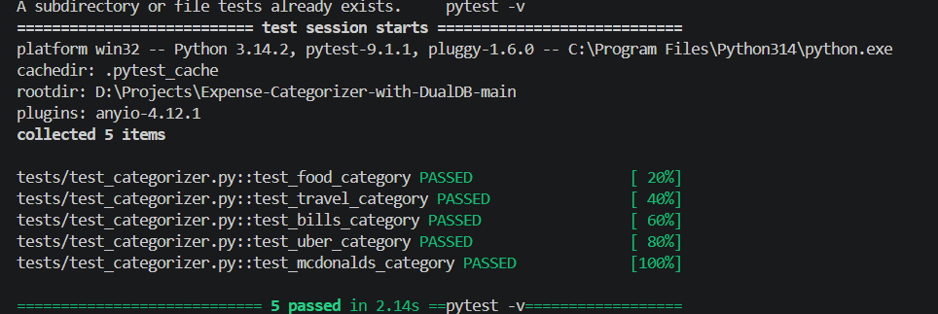

5.2 Input Validation Testing
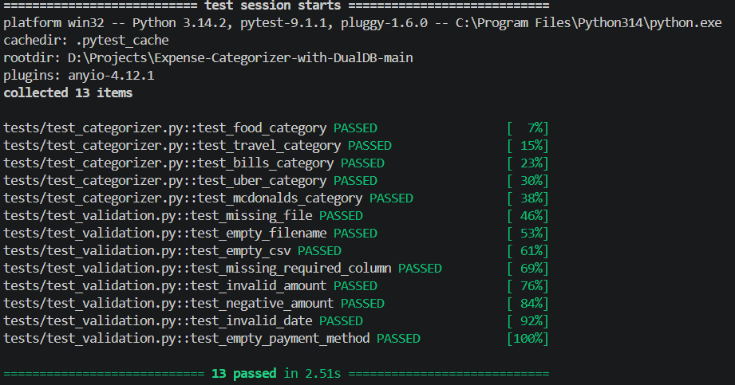
The application was tested with invalid input scenarios including:
- Missing CSV file
- Empty filename
- Empty CSV
- Missing required columns
- Invalid amount
- Negative amount
- Invalid date
- Empty payment method
The application correctly rejected invalid inputs and returned appropriate error responses.
Result: PASS

5.3 Successful CSV Upload Testing
A valid CSV file containing expense records was uploaded through the API.
The test verified:
- CSV processing
- Input validation
- ML category prediction
- MySQL operations
- MongoDB insertion
- Successful API response
Result: PASS
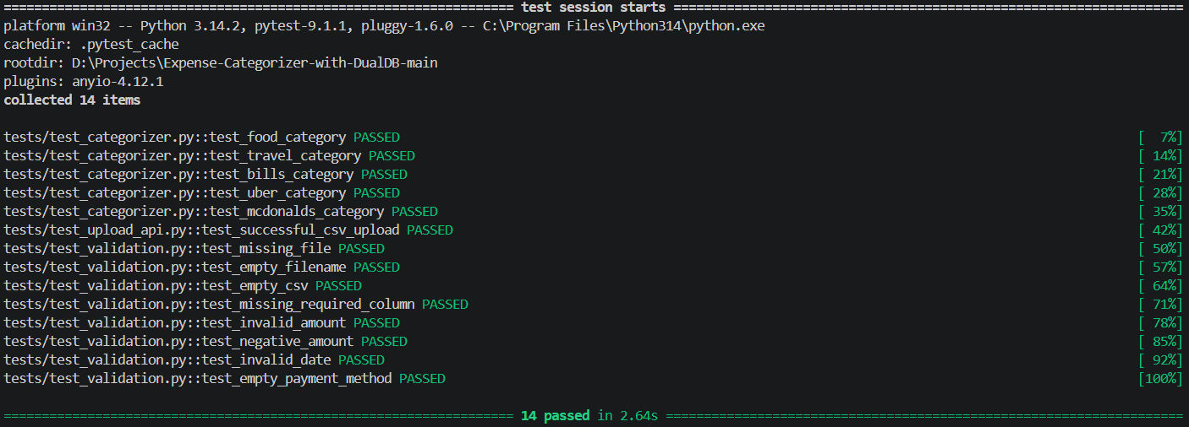

5.4 MySQL Failure and Rollback Testing
A MySQL insertion failure was simulated using mocking.
The test verified that:
- The API returns an error response.
- The MySQL transaction is rolled back.
- The transaction is not committed after failure.
Result: PASS
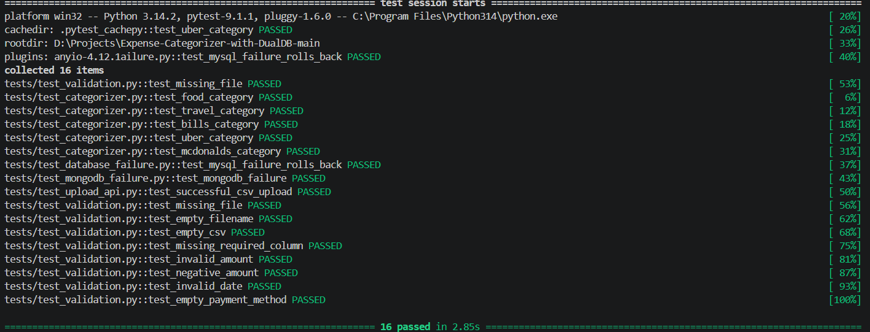

5.5 MongoDB Failure Testing
A MongoDB insertion failure was simulated.
The test verified that the application handles the MongoDB failure and returns an appropriate server error response.
Result: PASS
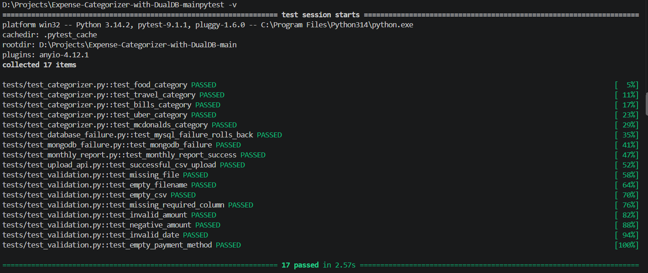

5.6 Monthly Report Testing
The monthly report API was tested using:
GET /monthly_report/1/2025
The test verified that category-wise monthly expense totals were returned correctly.
Result: PASS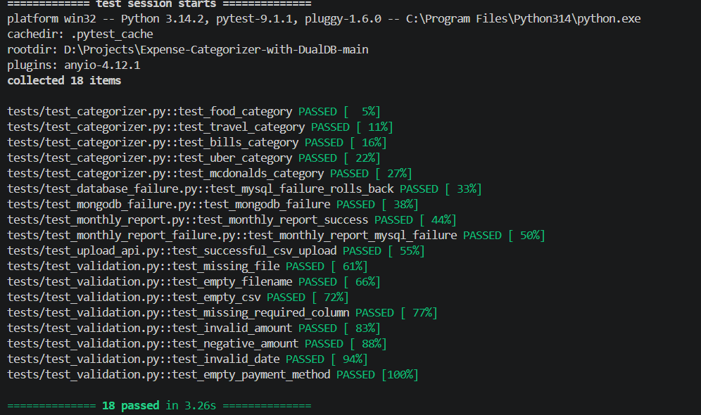

5.7 Monthly Report Failure Testing
A MySQL connection failure was simulated while requesting the monthly report.
The application correctly returned an HTTP 500 server error.
Result: PASS
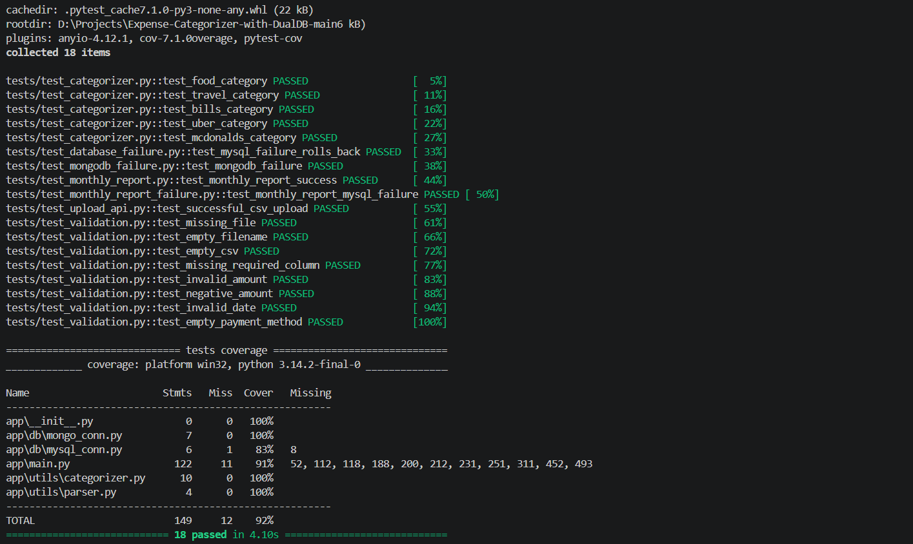
6. Code Coverage
Code coverage was measured using pytest-cov.
File | Coverage
app/init.py | 100%
app/db/mongo_conn.py | 100%
app/db/mysql_conn.py | 83%
app/main.py | 91%
app/utils/categorizer.py | 100%
app/utils/parser.py | 100%
Overall | 92%
The automated test suite achieved 92% overall code coverage.
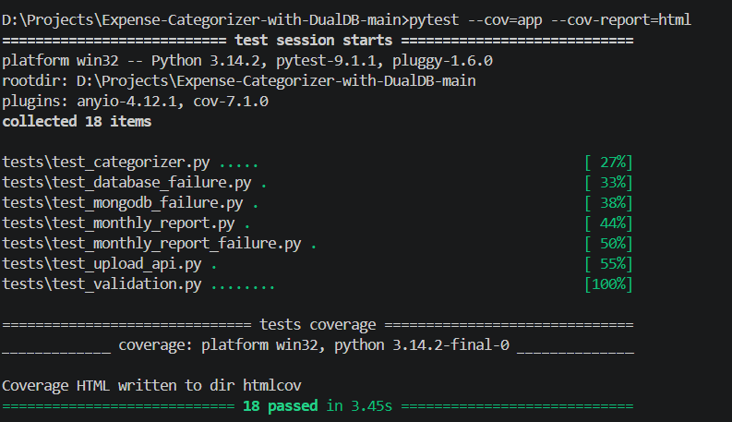

7. Machine Learning Evaluation
The ML model was evaluated separately using test datasets.
Dataset | Samples | Correct Predictions | Accuracy
Unseen Test Data | 30 | 30 | 100%
Hard Contextual Test Data | 15 | 14 | 93%
The harder dataset contained more contextual examples and resulted in one incorrect prediction.
This demonstrates that the model performs well on the prepared datasets but can still make errors on ambiguous real-world inputs.
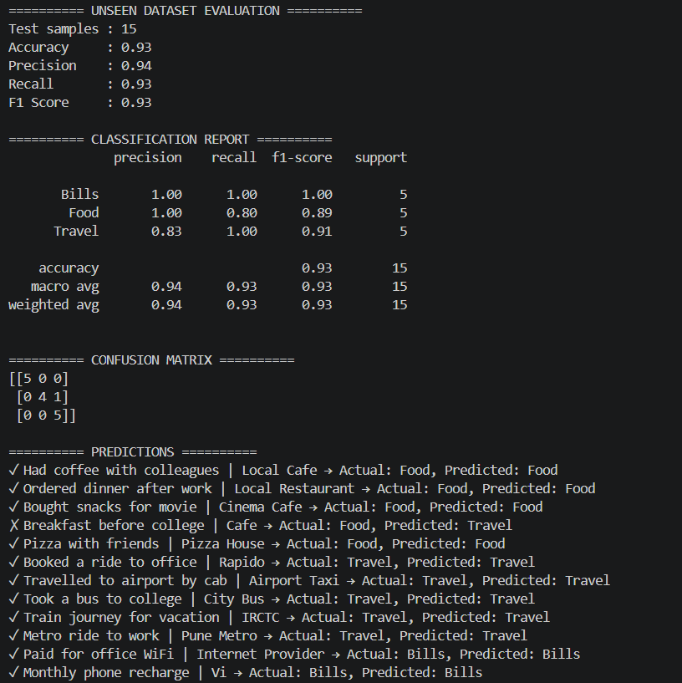

8. Defects Identified and Fixed
During testing, the following issues were identified and addressed:
- Invalid CSV values could reach the database without proper validation.
- Empty CSV files were not handled correctly.
- Empty payment method values required additional validation.
- Database failure scenarios required proper rollback and error handling.
- Automated tests were added to prevent regression of these issues.

9. Test Result
The final automated test execution produced:
18 passed
0 failed
The application achieved:
100% test case pass rate
and
92% overall code coverage.

10. Conclusion
Testing of the Expense Categorizer with Dual Database application was completed successfully.
The testing covered the major application functionalities including Machine Learning categorization, CSV validation, API operations, MySQL and MongoDB interactions, database failure handling, transaction rollback, and monthly reporting.
The final test execution resulted in 18/18 passing tests, providing a reliable automated regression baseline for the project.

